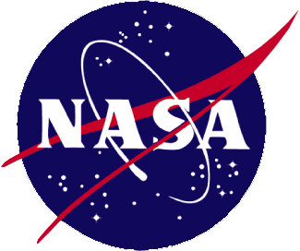

National Program Goal and Objectives

Goal:

Contribute to the nation's science enterprise by funding education, research, and public service projects through a national network of university-based Space Grant consortia.

Objectives:

- Establish and maintain a national network of universities with interests and capabilities in aeronautics, space and related fields.
- Encourage cooperative programs among universities, aerospace industry, and Federal, state and local governments.
- Encourage interdisciplinary training, research and public service programs related to aerospace.
- Recruit and train U.S. citizens, especially women, underrepresented minorities, and persons with disabilities, for careers in aerospace science and technology.
- Promote a strong science, mathematics, and technology education base from elementary through secondary levels.

